Fall 2024 Intro to Computer Networks (CSCI-2303 - 10102)

## Nilufar Babayeva

### Assignment 1

Task 1.

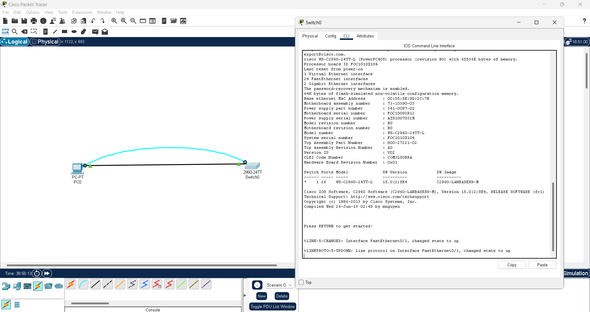

Task 2.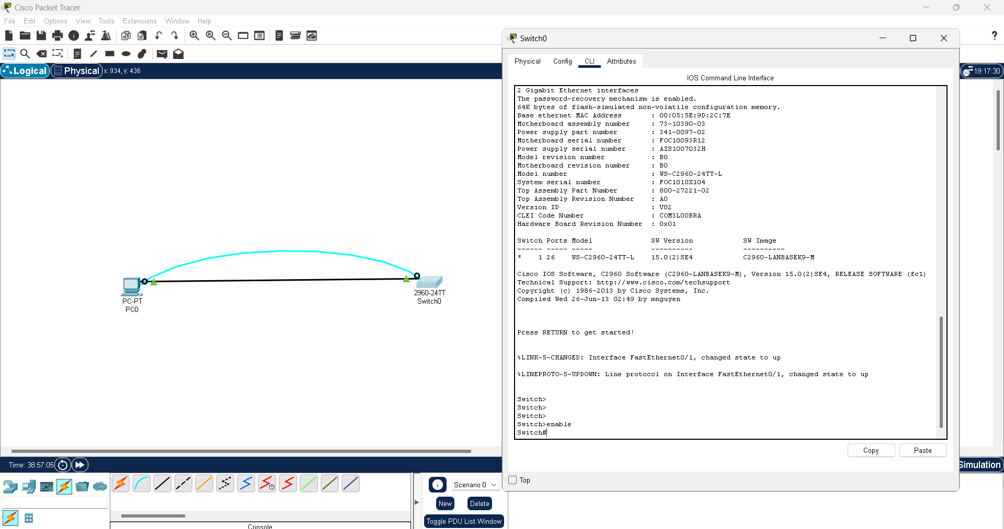

Task 3.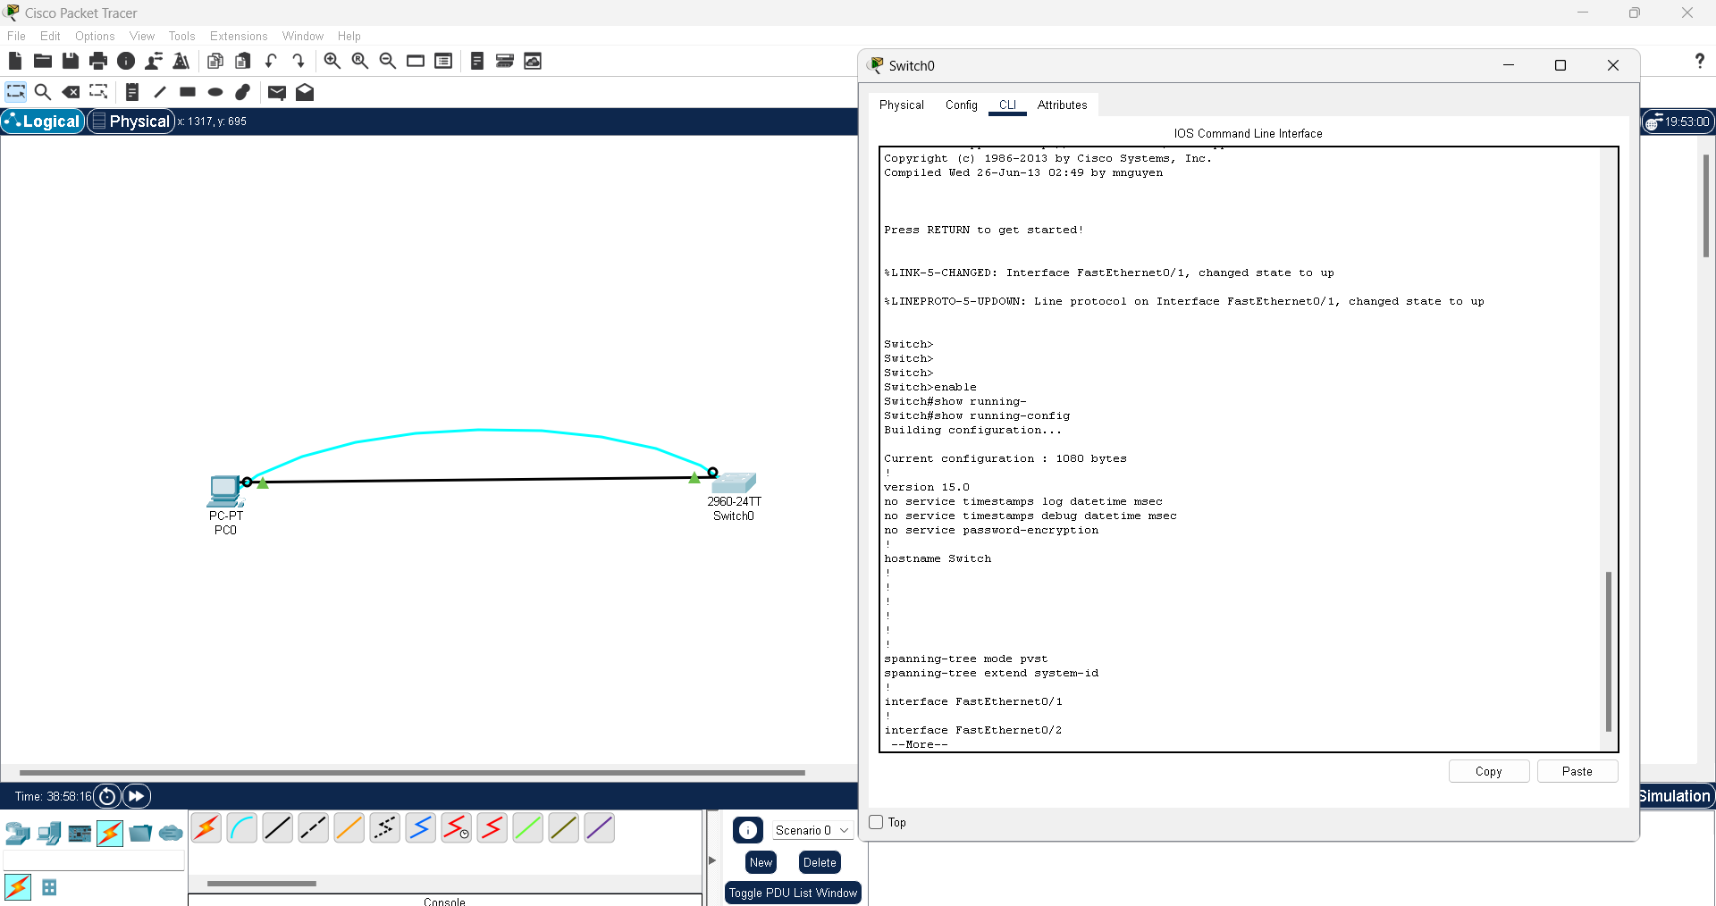

Task 4.

(Assign a name to a switch, secure access to the console line)

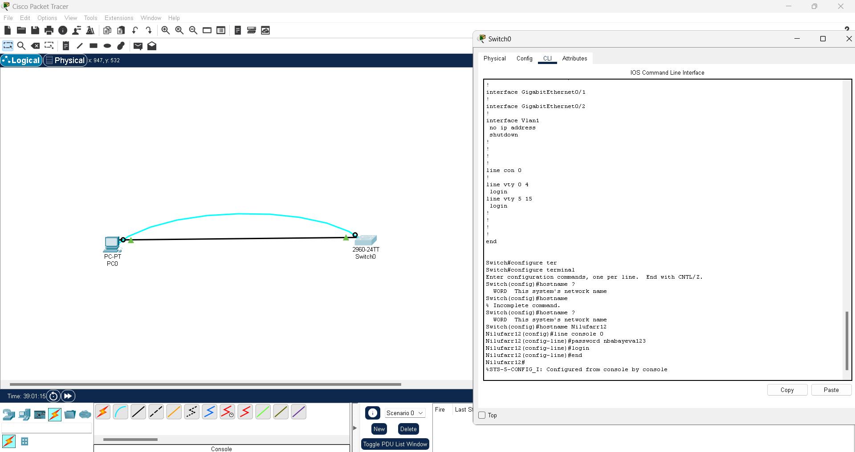

(Secure privileged mode access)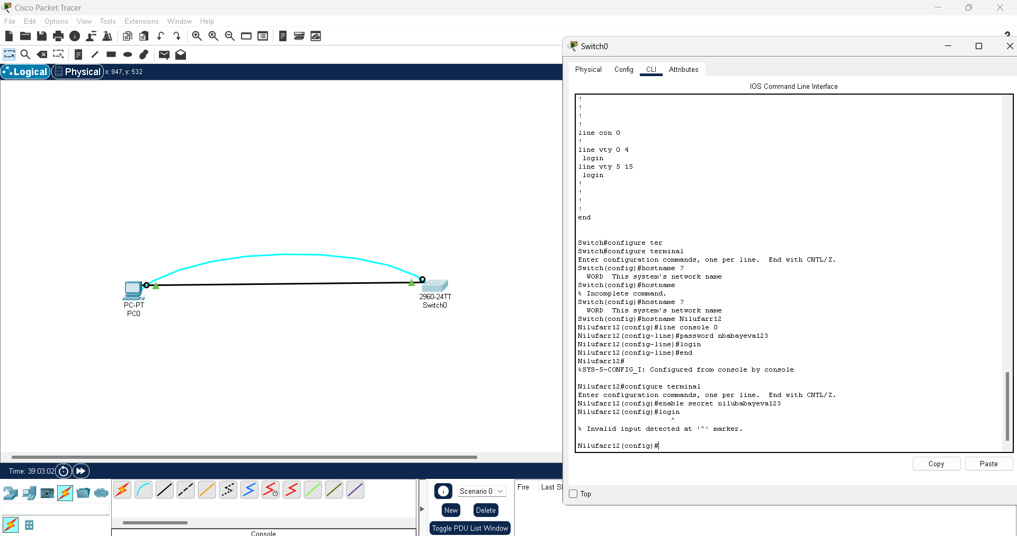

(Configure an encrypted password to secure access to privileged mode)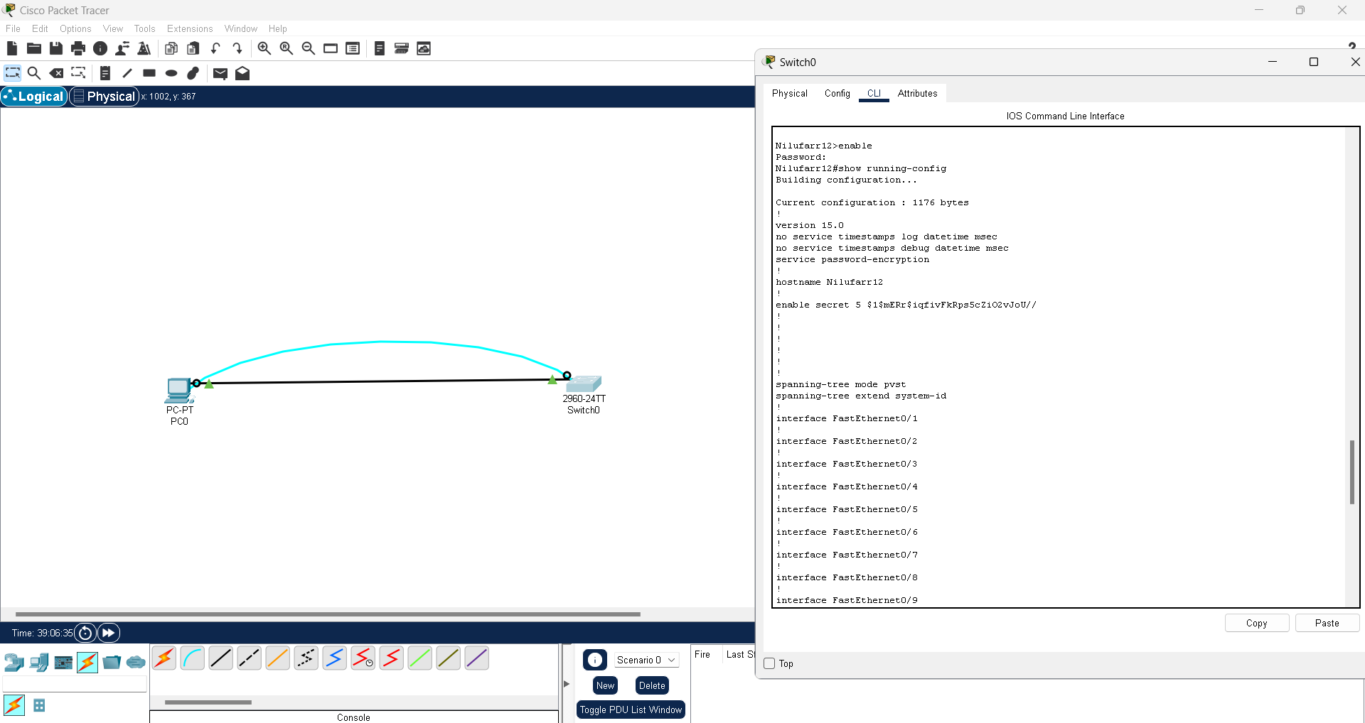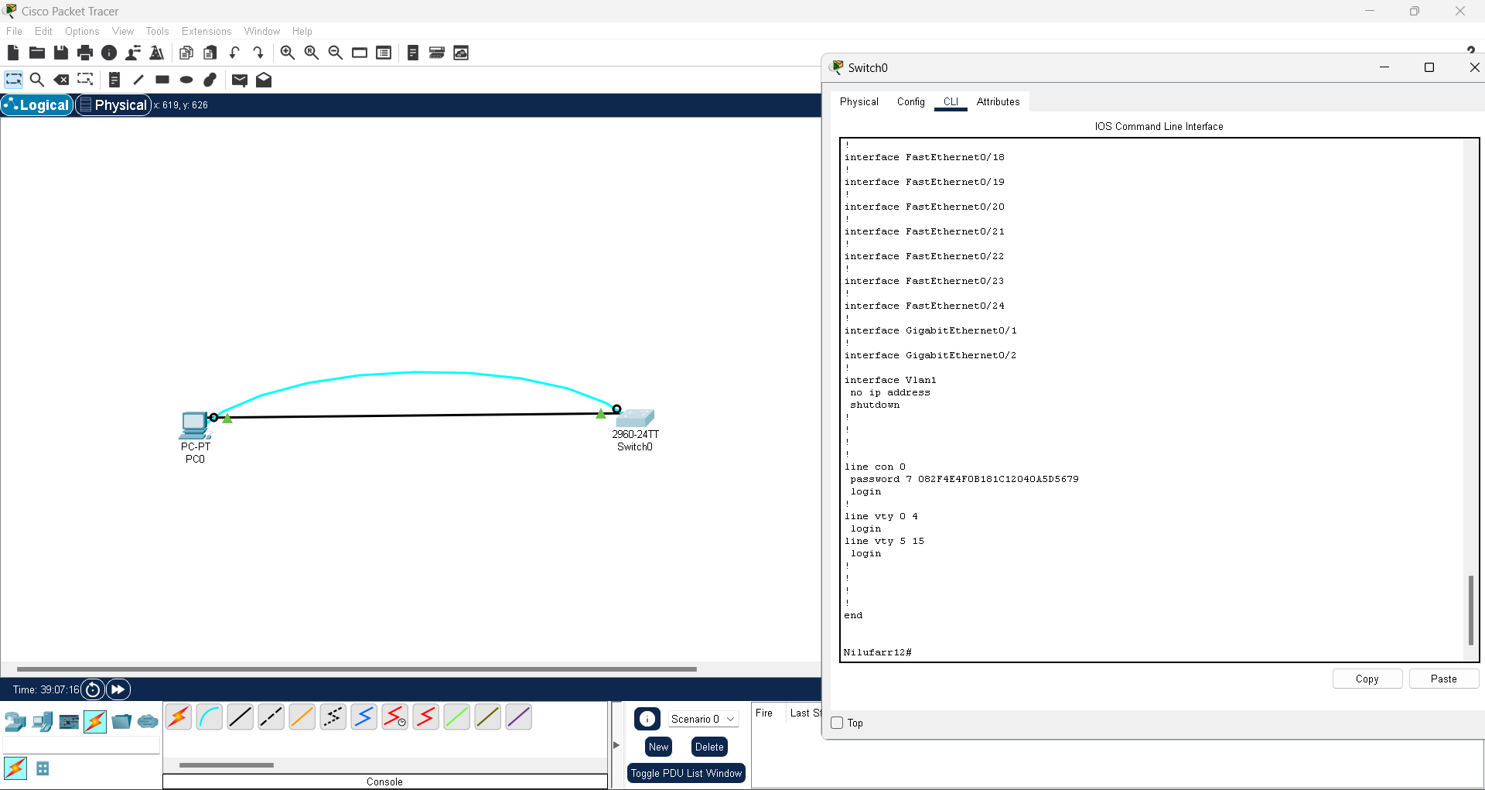

(Configure a MOTD Banner.)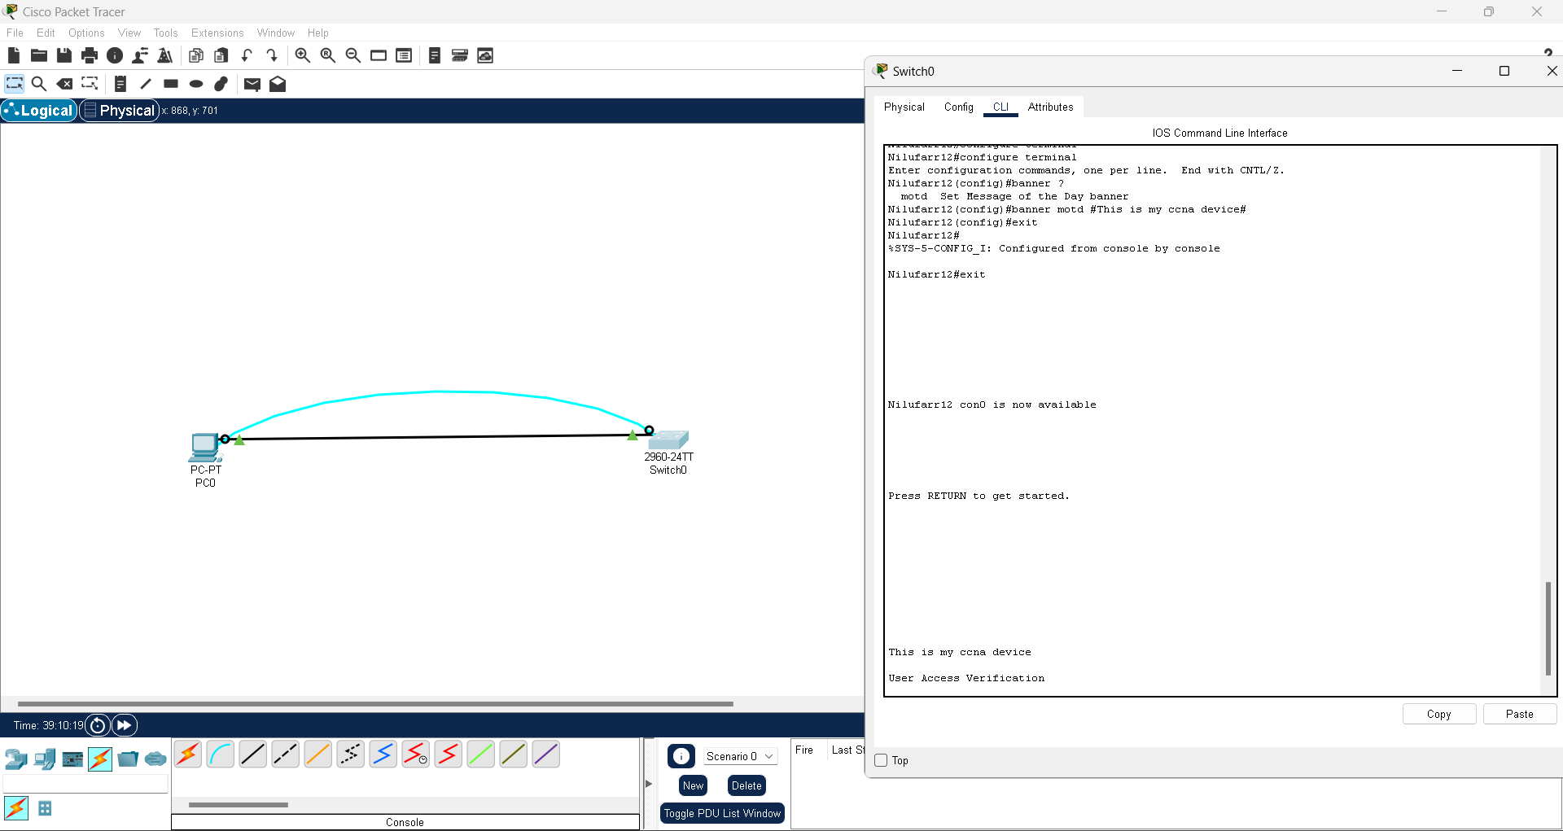

Task 5.